Nonprofit Leadership & Development

COM 466 FALL- 17 MONDAY 6:00 – 8:45pm **A Service-Learning class

SUMMER I - 2017 MON - THU 5:30 – 7:25pm 3 credit hours
Required course for the Nonprofit Minor; Departmental Elective for Communication Majors
Concentration Elective for Public & Interpersonal Communication Majors; NO Pre-Req’s
OPEN TO ALL MAJORS [Service hours are required: minimum 15 summer & 30 in the fall ]

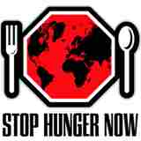
Nonprofit Leadership and Development is a service-learning course that challenges students to make a 15(summer) to 30 hour (Fall & Spring) commitment to service in a local nonprofit organization throughout the semester. Students will critically examine theories of communication and leadership with the following Learning Outcomes:
- Compare different styles of leadership; analyze when they are used appropriately
- Evaluate the effectiveness of a nonprofit organization’s capacity-building
- Evaluate the effectiveness of a strategic plan, vision, and mission statement
- Analyze options for resource development and generate fundraising strategies
- Identify the challenges of nonprofit governance and practice strategies for improving

communication with the board or trustees, staff, and volunteers
- Analyze communication strategies for diverse constituents in challenging situations
- Think and write both critically and professionally
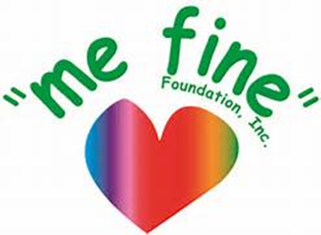

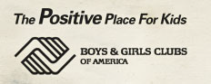
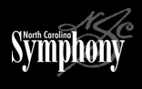
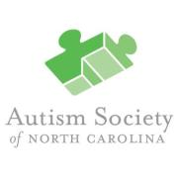
In addition, the course will emphasize these five Nonprofit Leadership Challenges as threaded throughout the Minor in Nonprofit Studies:
- Aligning mission, methods, and resources
- Earning the public trust
- Balancing individual interest and the common good

- Capitalizing on opportunities associated with diversity
- Moving beyond charity to systemic change

Course Requirements:
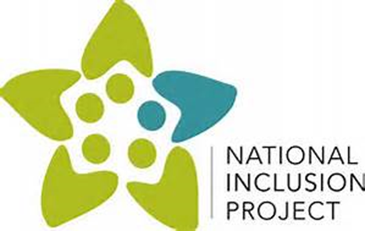
- Read from course text book and selected current nonprofit journals & publications

- Provide/acquire transportation to/from sites and purchase of internship insurance.
- Participate fully in class activities as a key component of COM 466; possible quizzes but no exams.
- Give 15 (summer) to thirty hours of individual service to a selected Nonprofit Partner as a team member
- Create and present In-Class Team Final Presentation on Nonprofit Partnership & Service Experience
- Write up to five short (1-3 page) Journals and up to five (5- 7 pp) Articulated Learning papers
**Please AVOID ADDITIONS to FALL after Aug. 21 or SUMMER class after MAY 15 as Agency partner teams are selected by then & there are 2 critical small assignments due before class begins. Adding then is really tough on the student & partner **

Some previous service learning Nonprofit Partners include:

- Susan G. Komen Triangle to the Coast LGBT Center of Raleigh
- Boys & Girls Clubs of Raleigh & Wake County Raleigh City Museum
- Big Brothers – Big Sisters of Wake County NC Science Olympiad
- STOP Hunger Now ARTS NC State NC Science Engineering Fdtn.

Selected skills enhanced or developed in COM 466 include:
- Volunteer recruitment, training, evaluation, appreciation and development
- Persuasive, interpersonal & public speaking Event planning

- Critical thinking, writing and editing Marketing and promoting


- RFP, grant-writing and fund-distribution Conflict resolution
FMI: Instructor Mindy Sopher: mbsopher@ncsu.edu 919-515-5616

